Post Bill of Exchange Vendor (Imports)

S.NO. : 01-FI-AP-06

TRANSACTION CODE : F – 40

ACCESS PATH : SAP Easy Access Accounting Financial
Accounting Document Entry Bill of Exchange
Payment

On the screen “ Bill of exchange Payment: Header Data”, enter information in the fields as specified table below:

Required fields:

Document date : To be entered
Document Type : Defaults to “KZ”
Company Code : Default (after entered for First Time)
Posting Date : Default (after entered for First Time)
Period : Default (after entered for First Time)
Currency : Default at INR to be changed to Euro
Transaction to be
Processed : Defaulted at outgoing payment
Posting Key : Default
Account : To be entered
Spl. G/L Ind. : Default (at “W” –Bill of exchange – Bankable)

We get the “Bill Of Exchange Payment – Header Data” screen as below

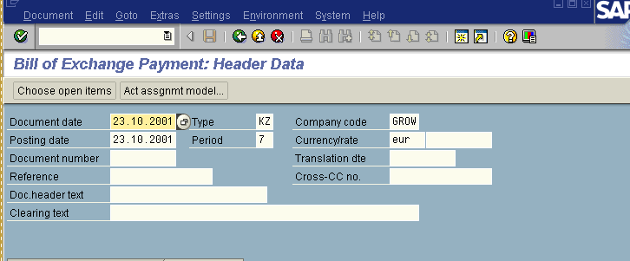
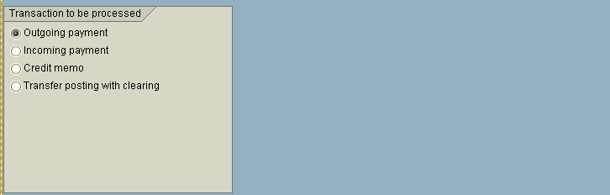

On the above “Bill Of Exchange Payment – Header Data” screen

Press button

We will get “Bill Of Exchange Payment - Add Vendor Item” Screen

Required fields;

mount : To be entered in EURO currency & Inr currency
Due Date : To be entered

Rest all items viz; Drawer,Drawee details etc. are by default.

After Incorporating the above data in the above “Bill Of Exchange Payment - Add Vendor Item” Screen we get the display as hereunder;

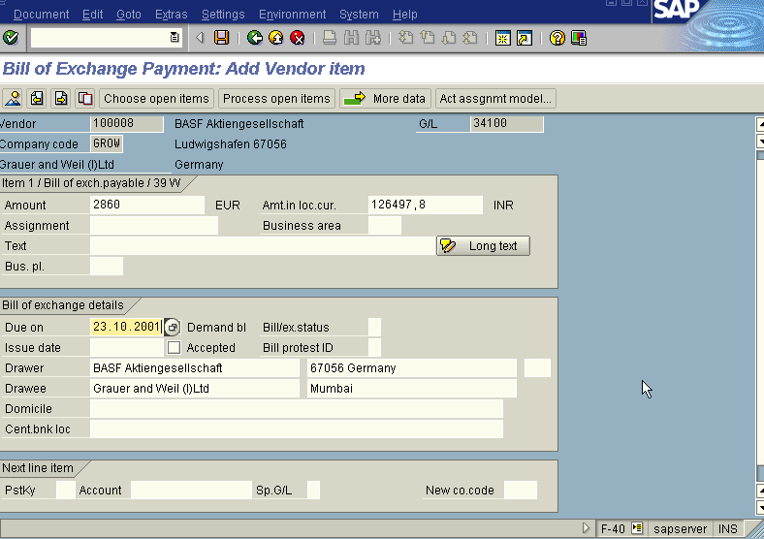

In the above “Bill Of Exchange Payment - Add Vendor Item” Screen

Press button

The system displays the following message as under

Press enter button

We get the “Bill Of Exchange Payment - select open items” screen

In the above “Bill Of Exchange Payment - select open items” screen the fields viz; company code, account (Vendor account number), account type appear as default. The screen will be displayed as under
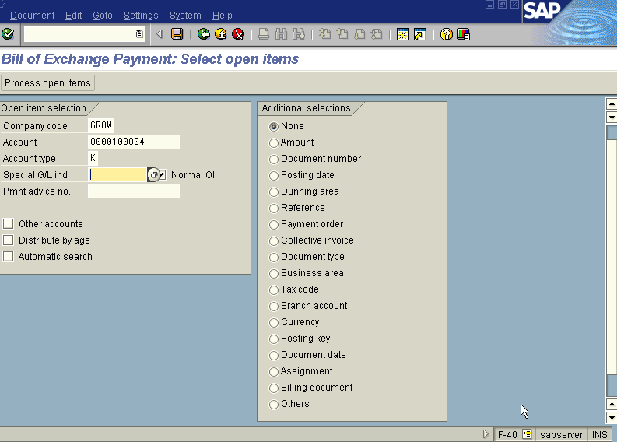
In the above “Bill Of Exchange Payment - select open items” screen, We leave the SPL. G/L Indicator field blank because we are clearing the bill of exchange against the invoice

Press button

We get “Bill of Exchange Payment – Process open items” screen as under

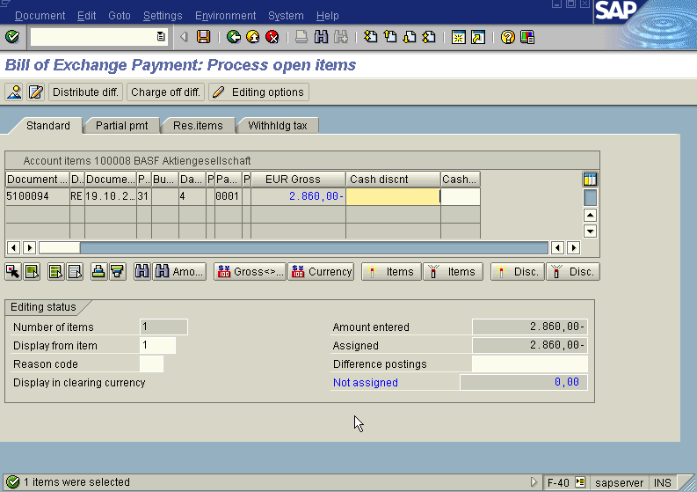

In the above “Bill of Exchange Payment – Process open items” screen

Press icon (Select all) so that all items will be highlighted in blue.

Press icon (Deactivate items) so that all items highlighted in blue turns to normal in black

Now use the Scroll bar on the above “Bill of Exchange Payment – Process Open Items” screen till you find your Invoice on the above Screen. Then once we have found the Invoice we wanted to post, Just just double click with the mouse on the Amount field eg. 2860 Euro in this case so the amount highlighted will turn to blue colour and the Not assigned field will turn to Zero . Here we should keep in mind that this Not assigned field has to be brought to zero to make the posting.

Press Save button

Take a note of the document number ; 1500104

This is the stage where “Bill of Exchange Payment” stage is complete

The document can be seen from Document Display from the top left hand side of the main screen “post out going payment - Header Data“ OR from Transaction code FB- 03 .The Document overview screen will be displayed as under showing the entries.

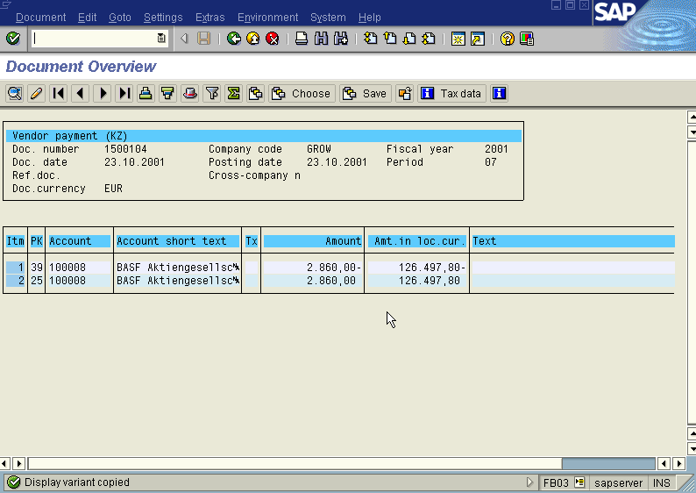

In the above screen the field amount in local currency can be got by chossing button and we are displayed with “Display Variant choose” screen as under

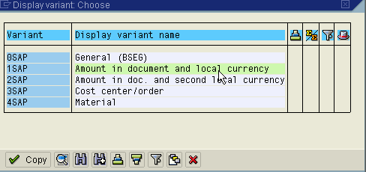

In the above screen choose variant Amount in document and local currency so that in the above “Document Overview” screen showing the entries passed the amount field will appear in Euro & Inr currency.

To know the exchange rate quoted press (Document Header) Icon from “ Document Overview” screen. We get “ Document Header – Company Code GROW” screen as under from which we can see the exchange rate quoted as under.

